**Carrot Ginger Soup**

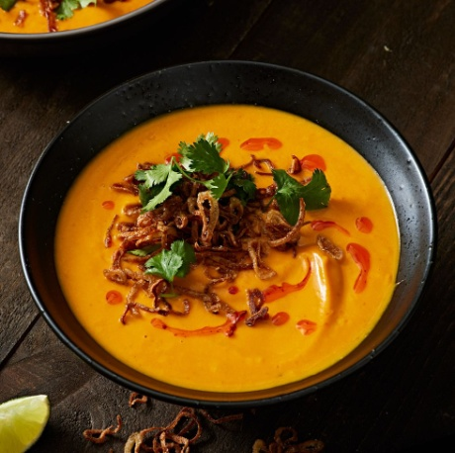

**INGREDIENTS**

* **2** **tbsp.** coconut oil or other neutral oil
* **1** 4-inch piece of fresh ginger, peeled and roughly chopped
* **1** small shallot, roughly chopped
* **2** large garlic cloves, chopped
* **2** **lb.** carrots, peeled and roughly chopped
* **1** **tbsp.** red curry paste
* **2** **1/4** **c.** chicken or vegetable stock
* **1** (14-oz.) can full-fat unsweetened coconut milk
* **1** **tbsp.** fish sauce
* Kosher salt
* Zest and juice of half a lime
* Chopped cilantro, for garnish
* Fried shallots (optional)
* Chili oil (optional)

**METHOD**

1. Step 1In a large pot, heat the oil over medium-high heat. Add the ginger, shallots, and garlic and cook until soft and just starting to brown, about 4 minutes. Add the carrots and curry paste and stir well. Cook for 2 more minutes
2. Step 2Pour in the stock, coconut milk, and fish sauce and season with a generous pinch of salt. Bring the soup to boil, reduce to a simmer, and cook for 10-15 minutes, or until the carrots are soft. Add the lime zest and juice.
3. Step 3Carefully transfer to a blender and blend until smooth. (You may need to do this in two batches.) Taste and adjust for salt and lime.
4. Step 4Serve soup warm garnished with cilantro.